Download create sakila db and sakila db exercises files from MS Teams Classwork page.

* Start MySQL Workbench
* Select and start Local instance

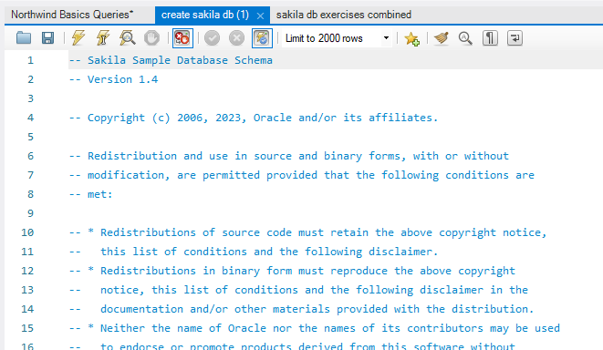

* Enter your password
* Select File
* Select Open SQL Script File
* You can also use CTRL + Shift + O keys
* Another way is to choose symbol.
* Select and open create sakila db file.
* If you are working on online sql you will complete challenges on hackerrank website.